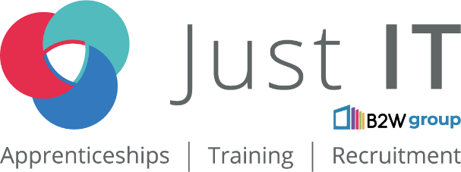

**Data Technician**

|  |
| --- |
|  |

|  |
| --- |
| **Name: Maduka Chinemelum Ogwueleka** |
| **Course Date: 06/01/2025** |
|  |

**Table of contents**

Day 1: Task 1 3

Day 1: Task 2 3

Day 1: Task 3 4

Day 2: Task 1 5

Day 3: Task 1 9

Day 3: Task 2 10

Day 3: Task 3 11

Day 4: Task 1 12

Day 4: Task 2 13

1. Scenario Background 13

2. Data Laws and Regulations 14

3. Azure Service Recommendations 14

4. Data Types and Data Modelling 14

5. Data Storage Formats and Structures in Azure 14

6. Additional Considerations 15

Submission Guidelines: 15

Course Notes 17

Additional Information 17

# Day 1: Task 1

Please research and complete the below questions relating to key concepts of cloud.

Be prepared to discuss the below in the group following this task.

|  |  |
| --- | --- |
| **What can cloud computing do for us in the real-world?** | 1. File storage 2. Big Data Analytics 3. Data Backups and Archiving 4. Disaster Recovery 5. Software testing and development 6. Infrastructure as a service (IaaS) and Platform as a service (PaaS) 7. Communication 8. Social Networking 9. Business Process: Example is Customer Relationship Management (CRM) |
| **How can it benefit a business?** | Cloud computing gives your business more flexibility. You can quickly scale resources and storage up to meet business demands without having to invest in physical infrastructure. Companies don't need to pay for or build the infrastructure needed to support their highest load levels. |
| **What’s the alternative to cloud computing?** | The primary alternative to cloud computing is "on-premise" hosting, where a company maintains its own physical servers and infrastructure within its own data center, giving them complete control over their systems and hardware, instead of relying on a remote cloud service.  Edge Computing: Processing data closer to its source on devices like IoT sensors, rather than sending it to a central cloud.  Fog Computing: A distributed computing model where data is processed at the network edge, similar to edge computing but with a more decentralised approach. |
| **What cloud providers can we use, what are their features and functions?** | Some of the most prominent cloud providers include Amazon Web Services (AWS), Microsoft Azure, Google Cloud Platform (GCP), IBM Cloud, Oracle Cloud Infrastructure (OCI), and DigitalOcean, each offering a range of services like compute power, storage, networking, databases, analytics, and more, with varying strengths depending on your specific needs and integration requirements; key features to consider include scalability, reliability, cost structure, global reach, and compatibility with your existing systems. |

# Day 1: Task 2

Please research the below cloud offerings, explain what they are and examples of use cases.

|  |  |  |
| --- | --- | --- |
| **Cloud Offerings** | **Explain what it is** | **When / how might you use this service in the real-world?** |
| **IaaS (Infrastructure as a service)** | This is a type of cloud computing service that offers essential compute, storage, and networking resources on demand, on a pay-as-you-go basis. | When you need to quickly set up and scale a computing environment without having to invest in physical servers, like when a company experiences sudden spikes in website traffic during a sale, needs to launch a new product quickly, or wants to run large-scale data analysis without managing their own data centre infrastructure. |
| **PaaS (Platform as a service)** | This is a type of cloud computing service model that offers a flexible, scalable cloud platform to develop, deploy, run, and manage applications (Apps). | When you need to quickly develop and deploy a web application without having to manage the underlying infrastructure like servers and operating systems, allowing developers to focus on coding and building features instead of managing hardware; for example, a small business could use a PaaS like Google App Engine to create an online store with features like user accounts, product listings, and payment processing, without needing to set up and maintain their own servers. |
| **SaaS (Software as a service)** | This is a model where software applications are hosted on a remote server by a third-party provider and accessed by users over the internet through a web browser, typically on a subscription basis, eliminating the need to install and manage software locally on individual devices; essentially, you "rent" the software instead of buying it outright. | Software as a service (SaaS) allows users to connect to and use cloud-based apps over the Internet. Common examples are email, calendaring, and office tools (such as Microsoft Office 365). |

# Day 1: Task 3

Please research the below terms and explain what they are, when they would be appropriate and a real-world example of where it could be implemented (i.e. what type of organisation).

|  |  |
| --- | --- |
| **Public Cloud** | A public cloud is a type of cloud computing that provides on-demand access to computing resources over the Internet. Public clouds are offered by third-party providers and are available to anyone who wants to use them.  A third-party provider owns and manages the hardware, software, and infrastructure.  Users access the resources through a web browser.  Users pay for the resources they use, such as storage, bandwidth, or CPU cycles.  They advantages are that Public Cloud is cost effective, reliable, scalable, innovative and efficient.  Examples of Public Cloud are Microsoft Azure, Amazon Web Services (AWS), and Google Cloud Platform (GCP). |
| **Private Cloud** | The private cloud is defined as computing services offered either over the Internet or a private internal network and only to select users instead of the general public.  Private clouds can be hosted on-site or by a third-party service provider.  The hardware and software are dedicated to the organisation.  Private clouds use a private network to maintain services and infrastructure.  Private clouds use company firewalls and internal hosting to ensure that sensitive data is not accessible to third parties.  Private clouds are often used by government agencies, financial institutions, and other large organisations with business-critical operations/infrastructure.  The advantages include the following: 1. Private clouds offer a higher level of security and privacy than public clouds. 2. Private clouds offer more control over resources, access, and customisation. 3. Private clouds can be more scalable than on-premises infrastructure. 4. Private clouds can be customised to meet specific business needs.  The disadvantages are that Private Clouds are expensive, and the IT departments of companies are responsible for managing the Private Clouds. |
| **Hybrid Cloud** | A hybrid cloud combines a private cloud and a public cloud. It allows data and applications to be shared between the two clouds.  A hybrid cloud uses a combination of computing, storage, and services.  It allows data and applications to move between the public and private cloud platforms.  It uses connective tools and protocols like APIs, VPNs, and WANs to share information between platforms.  Organizations use hybrid clouds to meet regulatory and data sovereignty requirements.  They can also use it to take advantage of on-premises technology investments.  Hybrid clouds can help address low latency issues .  They can be a cost-effective way to manage large amounts of data.  The disadvantages of Hybrid clouds are:   1. They can increase the risk of data breaches. 2. IT departments may struggle to handle the increased complexity. 3. The process of managing a hybrid cloud model can be resource-heavy. |
| **Community Cloud** | A community cloud is a shared cloud infrastructure that allows organisations with similar goals to collaborate and exchange data. It's a semi-public cloud that is more private than a public cloud.  Organisations with common goals, such as a mission or security requirements, share infrastructure.  The infrastructure can be hosted on-premises or off-premises.  One or more organisations in the community can own, manage, or operate the infrastructure.  The goal is to foster collaboration, networking, and data exchange while maintaining high security standards.  Some advantages of Community Clouds are:   1. Organisations can share the responsibility of maintaining the cloud. 2. Organisations can benefit from the shared infrastructure without being individually responsible for it.   Examples of community cloud providers are:   1. **Hewlett Packard Enterprise (HPE)**: Offers the HPE Ezmeral platform and Helion OpenStack cloud platform. 2. **Salesforce**: Offers a community cloud with features such as sales force automation, sales engagement, and sales analytics. |

# Day 2: Task 1

Describe, with examples, the **three** major areas that the Computer Misuse Act deals with.

|  |  |  |
| --- | --- | --- |
| **Area** | **Description** | **Example** |
| **Unauthorised Access to Computer Materials** | It is an offence for a person to cause a computer to perform any function with the intent to secure access to any program or data held in any computer unauthorised. | If a student finds out a teacher's password and then accesses their computer and opens their files. |
| **Unauthorised access with intent to commit or facilitate commission of further offences.** | The maximum penalty on indictment is 5 years imprisonment.  The offence under Section 2 is committing the unauthorised access offence under Section 1 with intent to commit or facilitate the commission of a more serious 'further' offence. It is not necessary to prove that the intended further offence has actually been committed. | Examples of such offences are obtaining the unauthorised access with the intention of committing theft, such as by diverting funds, which are in the course of an electronic funds transfer, to the defendants own bank account, or to the bank account of an accomplice; or where the defendant gained unauthorised access to sensitive information held on computer with a view to blackmailing the person to whom that information related. |
| **Unauthorised modification of computer files.** | The maximum sentence on indictment is 10 years' imprisonment.  The effect of Section 3 is that a person commits an offence if he performs any unauthorised act in relation to a computer, knowing it to be unauthorised, if he intends by doing the act to do one of the things set out in Section 3(2), or if he is reckless as to whether by doing the act he will do one of the things set out in Section 3(2). | Examples of this are deliberate or reckless impairment of a computer's operation, preventing or hindering access to computer material by a legitimate user or impairing the operation or reliability of computer-held material. The offender must know that the act was unauthorised. |

The computer misuse act 1990 is an act where an individual can be criminalised because of computer related offense. Describe three extra powers that the Police and Justice Act 2006 (Computer Misuse) has added.

|  |
| --- |
| **Description** |
| **Increased penalties:** The Police and Justice Act (PJA) increased the maximum sentence for hacking into computer systems from five to ten years.  **Made DoS (Denial of Service) attacks illegal:** The PJA made DoS attacks a crime.  **Made hacking tool development illegal:** The PJA made it illegal to develop, distribute, or use hacking tools for criminal purposes.  **Created new offenses:** The PJA created new offenses for making, supplying, or obtaining articles for use in computer misuse offenses. |
|  |
|  |

Look at the below website to answer the questions:

<https://www.gov.uk/personal-data-my-employer-can-keep-about-me>

|  |
| --- |
| **Write down three items of data which a company can store about an employee.** |
| 1. **Name** 2. **Address** 3. **Sex** |
|  |
|  |

|  |
| --- |
| **Give three more examples of data that an employer can only store if they first get the employee’s permission.** |
| 1. **Race and Ethnicity** 2. **Genetics** 3. **Health and Medical Conditions** |
|  |
|  |

Conduct further research to answer the below questions.

|  |  |
| --- | --- |
| **Question** | **Answer** |
| **Provide one example of: Copyright infringement** | **Downloading copyrighted material**: Downloading music, movies, or software without the copyright owner's permission. |
| **Provide one example of: Plagiarism** | Submitting a paper written by another student as your own. |
| **What are two consequences of copyright infringement and software piracy?** | LEGAL CONSEQUENCE: Fines.  ECONOMIC CONSEQUENCE: Loss of revenue. |
| **Give three possible consequences for individuals when using pirated software** | 1. Legal consequences such as fines or lawsuits. 2. Exposure to malware or viruses due to the potentially corrupted software. 3. Lack of access to updates, technical support, and important features that come with a legitimate license. |

Listed below are some laws which we have covered today:

1. Computer Misuse Act 1990

2. Police and Justice Act 2006 (Computer Misuse)

3. Copyright, Designs and Patents Act 1988

4. Copyright (Computer Programs) Regulations 1992

5. The Health and Safety (Display Screen Equipment) Regulations 1992

6. Data Protection Act 2018

7. Consumer Rights Act 2015

* Insert a number in the first column of each row to match each of the statements with one of the above Acts.
* One of statements is incorrect and not illegal. For this statement, write ‘Not illegal’.

|  |  |
| --- | --- |
| **Act number** | **Clause** |
| 4 | With some exceptions, it is illegal to use unlicensed software |
| 7 | Any product, digital or otherwise, must be fit for the purpose it is supplied for |
| 1 | Unauthorised modification of computer material is illegal |
| Not illegal | It is illegal to create or use a hacking tool for penetration testing |
| 6 | Personal data may only be used for specified, explicit purposes |
| 5 | Employers must provide their computer users with adequate health and safety training for any workstation they work at |
| 2 | It is illegal to distribute hacking tools for criminal purposes |
| 6 | It is illegal to distribute an illicit recording |
| 6 | Personal data may not be kept longer than necessary |
| 1 | Gaining unauthorised access to a computer system is illegal |
| 5 | Employers must ensure that employees take regular and adequate breaks from looking at their screens |
| 1 | It is illegal to prevent or hinder access (e.g. by a denial-of-service attack) to any program or data held in any computer |
| 6 | Personal data must be accurate and where necessary kept up to date |

# Day 3: Task 1

Please complete the below lab (3) *‘Explore relational data in Azure’* and paste evidence of the completed lab in the box provided.

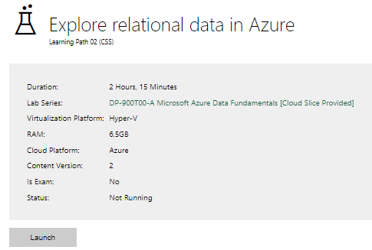

|  |  |
| --- | --- |
| **Completed lab** |  |

Complete the exercises below if finished early. [Azure Lab 1 Exercises](https://forms.office.com/e/kz2sCX75fc)

# Day 3: Task 2

Please complete the below lab (4) *‘Explore non-relational data in Azure’* and paste evidence of the completed lab in the box provided.

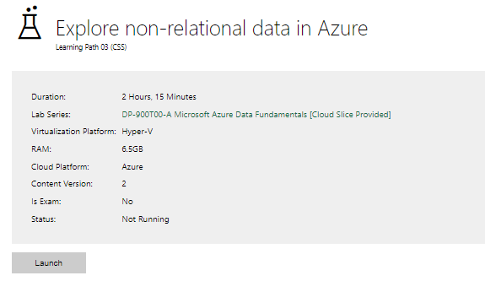

|  |  |
| --- | --- |
|  |  |
| **Completed lab** |  |

# Day 3: Task 3

Please complete the below lab (5) ‘Explore data analytics in Azure’ and paste evidence of the completed lab in the box provided.

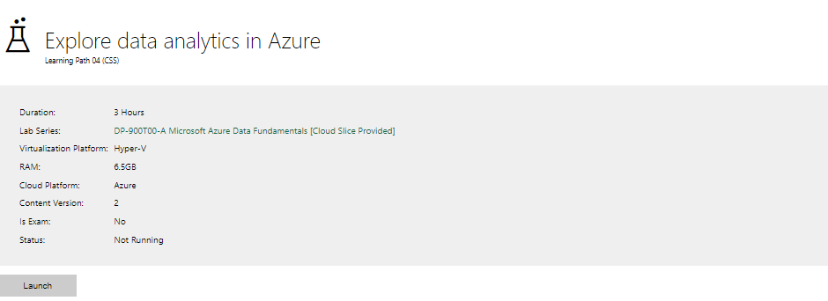

|  |  |
| --- | --- |
| **Completed lab** | It was showing a data server error, and I could not proceed. |

# Day 4: Task 1

In your teams, complete the Azure DP-900 practice exam and paste your result below – this is open book and please research and discuss your answers as a team.

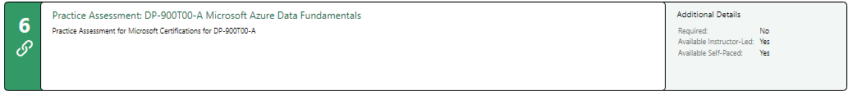

|  |  |
| --- | --- |
| **Result** |  |

# Day 4: Task 2

#### **1. Scenario Background**

"Paws & Whiskers" is a growing pet shop that aims to improve its business by analysing sales, customer information, and inventory data. Currently, the data is collected manually or stored in spreadsheets. Management is interested in transitioning to Microsoft Azure to streamline data storage, analysis, and reporting, enabling them to make data-driven decisions.

#### **2. Data Laws and Regulations**

Identify and explain the data laws and regulations relevant to handling customer data within the proposal. Ensure you cover the following points:

* **GDPR Compliance**: Highlight the importance of adhering to the General Data Protection Regulation (GDPR), particularly as it relates to storing and processing customer information.
* **Data Protection Act (DPA) 2018**: Outline how the DPA 2018 may affect the way "Paws & Whiskers" collects and stores data, ensuring compliance with UK laws on data privacy.
* **Other Industry Standards**: Research any additional data protection standards or regulations that may apply to pet shop data, particularly if they involve sensitive or payment information.

#### **3. Azure Service Recommendations**

Recommend Microsoft Azure services that would suit the company’s data analysis needs and explain why these services are suitable. Your recommendations should include:

* **Data Storage**: Identify suitable storage options, such as **Azure Blob Storage** or **Azure SQL Database**, and discuss the benefits of each for storing large datasets, including inventory, sales transactions, and customer details.
* **Data Analysis Tools**: Recommend tools such as **Azure Machine Learning** for customer behaviour analysis or **Azure Synapse Analytics** for analysing sales trends.
* **Data Integration and Automation**: Explain how services like **Azure Data Factory** could automate data collection and integration processes, improving efficiency.

#### **4. Data Types and Data Modelling**

Define the types of data "Paws & Whiskers" will need to work with and describe your approach to data modelling:

* **Data Categories**: Identify key data types, such as customer demographics, transaction history, pet inventory, and product categories.
* **Data Modelling Approach**: Outline how you would structure this data using a relational model or a data warehouse approach, considering factors like tables, entities, relationships, and primary keys.

#### **5. Data Storage Formats and Structures in Azure**

Discuss how you would store data within Azure and the formats you would recommend:

* **Data Formats**: Specify recommended formats (e.g., CSV for raw data imports, JSON for structured data, Parquet for analytics) and explain why these formats are suitable for specific data types.
* **Data Security and Encryption**: Include recommendations for securing data using Azure’s built-in encryption features and access controls to ensure compliance with data privacy regulations.

#### **6. Additional Considerations**

Provide any other considerations that might enhance data handling and efficiency in Azure, such as:

* **Backup and Disaster Recovery**: Outline a backup plan using **Azure Backup** or **Azure Site Recovery** to safeguard against data loss.
* **Data Visualisation**: Discuss potential use of **Power BI** within Azure for creating dashboards that provide management with real-time insights into sales and customer trends.
* **Future Scalability**: Comment on how Azure services can scale as the business grows, accommodating larger datasets and more complex analyses.

### **Submission Guidelines:**

1. **Structure**: Ensure your report is well-organised, with sections for each task (e.g., Data Laws, Azure Services, Data Types, etc.).
2. **Formatting**: Include headings, bullet points where appropriate, and any visuals or diagrams that support your explanations.
3. **References**: Cite any resources or regulations referenced in the report.
4. **Length**: Aim for 1500-2000 words.

|  |
| --- |
| DATA LAWS AND REGULATIONS:  1. GDPR (General Data Protection Regulation)  The General Data Protection Regulation (GDPR) is the toughest privacy and security law in the world. Though it was drafted and passed by the European Union (EU), it imposes obligations onto organisations anywhere, so long as they target or collect data related to people in the EU.  If you process the personal data of EU citizens or residents, or you offer goods or services to such people, then the GDPR applies to you even if you are not in the EU.  The fines for violating the GDPR are very high.  According to the GDPR, when processing and storing personal data, organisations must adhere to the principle of "storage limitation," meaning they can only keep data for as long as it is necessary for the intended purpose, and must delete or anonymise data when it is no longer needed; this is a key aspect of ensuring lawful and fair data handling under the regulation.  DATA PROTECTION ACT (DPA) 2018:  The Data Protection Act (DPA) 2018 is a UK law that regulates how organisations can collect, store, and use personal data, essentially updating the country's data protection laws to align with the European Union's General Data Protection Regulation (GDPR) and empower individuals to control their personal information; it came into effect on May 25, 2018.  The DPA 2018 is based on core principles like lawfulness, fairness, transparency, purpose limitation, data minimization, accuracy, storage limitation, and integrity and confidentiality.  Under the DPA 2018, individuals have rights to access their personal data, request correction, restrict processing, object to processing, and request erasure in certain circumstances.  AZURE SERVICES:  AZURE BLOB DATA STORAGE SERVICE:  Azure Blob Storage services store and access unstructured data at scale.  Azure Blob Storage will help the company to create data lakes for its data analytics requirement and also provide storage to build powerful cloud-native and mobile apps.  Azure Blob Storage can optimise costs with tiered storage for long-term data.  It can also flexibly scale up for high-performance computing and machine learning workloads.  AZURE SQL DATABASE:  Azure SQL Database is a fully managed relational database service that stores structured, semi-structured, and non-relational data.  It's built for the Azure cloud and includes built-in intelligence to improve performance, reliability, and data protection.  Some of the features of Azure SQL Database are:  1. Built-in intelligence: Learns app patterns and adapts them to improve performance, reliability, and data protection  2. Scalability: Scales on demand  3. Monitoring and troubleshooting: Includes built-in monitoring capabilities to help you get insights into workload characteristics  4. Data protection: Includes encryption, authentication, and continuous monitoring and auditing  5. Integration: Integrates with other Microsoft cloud services and open-source tools  6. High availability: Has a stated goal of 99.99% availability.  DATA ANALYSIS TOOLS FROM AZURE TO BE RECOMMENDED ARE:  1. AZURE MACHINE LEARNING:  Azure Machine Learning can be used to achieve the following:  A. Build models: Use Python or R to build models using a variety of algorithms.  B. Train models: Use high-performance computing capabilities to train models.  C. Deploy models: Publish models as web services that can be consumed by custom apps or BI tools.  D. Automate model development: Use automated machine learning (AutoML) to automate time-consuming tasks.  AZURE SYNAPSE ANALYTICS:  Azure Synapse Analytics is a Microsoft Azure service that combines data integration, big data analytics, and enterprise data warehousing. It helps users gain insights from their data faster.  AZURE DATA FACTORY:  Microsoft Azure Data Factory (ADF) is a cloud-based service that simplifies data integration and orchestration by moving information from diverse sources – on-premises databases, cloud platforms, and SaaS applications – and transforming it into actionable insights.  ADF can be very useful to a company struggling to connect disparate marketing and sales data for comprehensive customer analysis.  DATA TYPES AND DATA MODELLING IN AZURE:  In Azure, data types refer to the different formats data can be stored in, such as numbers, strings, dates, etc., while data modeling is the process of structuring and organising that data into entities, attributes, and relationships, typically using a visual representation to design a database schema, with popular Azure services like Azure Cosmos DB, Azure Databricks, and Power BI being used to implement these models depending on the data needs and analysis requirements.  DATA MODELING APPROACHES IN AZURE:  1. Relational data modeling: Using traditional relational databases like Azure SQL Database, where data is organized into tables with rows and columns, with defined relationships between tables.  2. NoSQL data modeling: Using Azure Cosmos DB to store flexible, document-oriented data where data is structured as JSON objects, allowing for more dynamic data structures.  3. Dimensional data modeling: For data warehousing scenarios, creating a star schema with fact tables and dimension tables to facilitate efficient analysis.  DATA STORAGE FORMATS AND STRUCTURES IN AZURE:  In Azure, data storage formats and structures primarily include:  1. Blob Storage for unstructured data like images and videos,  2. Queue Storage for message queuing.  3. Table Storage for structured key-value data.  4. Disk Storage for block-level storage attached to virtual machines.  5. Data Lake Storage for large-scale data analytics.  Other options are: Azure Cosmos DB for flexible schema-less data and Azure Synapse Analytics for data warehousing and analysis capabilities.  All of them use various data formats such as CSV, JSON, Avro, Parquet, and ORC depending on the specific storage service and use case.  DATA SECURITY AND ENCRYPTION IN AZURE:  In Azure, data security and encryption primarily rely on "Azure Storage Service Encryption (SSE)" which automatically encrypts data at rest using 256-bit AES encryption, ensuring data is protected when stored on the platform  Users can also manage encryption keys through Azure Key Vault for additional control.  In Azure, data in transit is secured using industry standard protocols like TLS and IPsec.  The benefits of Azure data encryption are:  1. Compliance: Helps meet data privacy regulations by ensuring sensitive data is encrypted at rest and in transit.  2. Data protection: Prevents unauthorised access to data even if it is compromised.  3. Transparency: Encryption is mostly managed by Azure, making it easy to implement.  AZURE BACKUP AND DISASTER RECOVERY:  In Azure, "backup and disaster recovery" refers to a comprehensive solution that allows users to protect their data by creating backups and enables them to quickly restore applications and services in case of a disaster, using services such as Azure Backup for data protection and Azure Site Recovery for automated failover to a secondary region in the event of an outage; essentially providing a way to recover from accidental deletion, malicious attacks, or other disruptions to normal operations, all within a cloud-based environment.  POWER BI WITHIN AZURE:  Within Azure, Power BI is primarily used to visualise and analyse large volumes of data stored in various Azure services like Azure Synapse Analytics, Azure Data Lake Storage, and Azure SQL Database, allowing users to create interactive reports and dashboards to gain insights and share them across an organisation, all while leveraging the scalability and security features of Azure; essentially, it acts as a powerful data visualization tool that seamlessly integrates with Azure's data analysis capabilities.  SCALABILITY OF AZURE:  Scalability in Azure is the ability to adjust resources to meet demand.  Azure offers both vertical and horizontal scaling, as well as automatic scaling.  1. Vertical scaling:  Involves adding resources to an existing server or virtual server. It can be used to quickly fix performance issues or handle spikes in workload. It can include adding CPU, memory, or storage resources.  2. Horizontal scaling:  Involves decomposing workloads into smaller microservices that can be scaled independently. It can be used to manage peak loads for highly transactional components.  3. Automatic scaling:  Automatically allocates resources based on workload demand. It can be used to anticipate and manage sudden increases in demand. It can automatically de-allocate resources when demand slackens.  Recommendations:  1. Consider using a combination of vertical and horizontal scaling.  2. Tailor your approach to the specific needs of your application and workload.  3. Define scale conditions or profiles based on time or metrics.  4. Configure notifications to send when an autoscale event occurs.  REFERENCES:  <https://www.wired.com/story/what-is-gdpr-uk-eu-legislation-compliance-summary-fines-2018/>  <https://www.dataprotection.ie/en/individuals/rights-individuals-under-general-data-protection-regulation>  <https://www.gov.uk/data-protection>  <https://www.itgovernance.co.uk/dpa-2018>  <https://azure.microsoft.com/en-gb/pricing/purchase-options/azure-account/search?ef_id=_k_CjwKCAiAnpy9BhAkEiwA-P8N4kV0Anm9AK6kIsr3jPio1XkZvCdXWkYW9vhvVOy9ZbXlG-TW06UjrxoCYhQQAvD_BwE_k_&OCID=AIDcmm3bvqzxp1_SEM__k_CjwKCAiAnpy9BhAkEiwA-P8N4kV0Anm9AK6kIsr3jPio1XkZvCdXWkYW9vhvVOy9ZbXlG-TW06UjrxoCYhQQAvD_BwE_k_&gad_source=1&gclid=CjwKCAiAnpy9BhAkEiwA-P8N4kV0Anm9AK6kIsr3jPio1XkZvCdXWkYW9vhvVOy9ZbXlG-TW06UjrxoCYhQQAvD_BwE> |

|  |
| --- |
| **Course Notes** |

It is recommended to take notes from the course, use the space below to do so, or use the revision guide shared with the class:

|  |
| --- |
| **Additional Information** |

We have included a range of additional links to further resources and information that you may find useful, these can be found within your revision guide.

**END OF WORKBOOK**

**Please check through your work thoroughly before submitting and update the table of contents if required.**

**Please send your completed work booklet to your trainer.**